1. c. Why do Tectonic plates move?
According to the theory of Plate Tectonics, the earth's tectonic plates are in constantly moving like giant 'rafts' on top of the semi-molten mantle below. This movement is very slow and vary from less than 2.5 cm per year to over 15 cm per year.
The movement of the earth's crustal plates is believed to be due to convection currents which occur in the semi-molten mantle. These convection currents are created by heat from within the earth - much of which is generated by radioactive decay in the core.
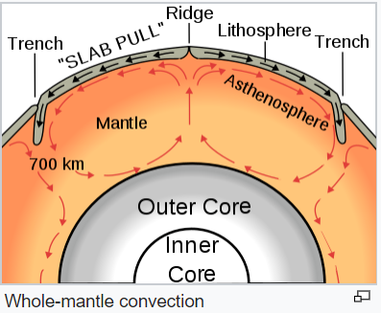
So how do convection currents cause plate movements?
As semi-molten rock in the mantle is heated it becomes less dense than its surroundings and rises. As it reaches the crust above, it spreads out carrying the plates above with it. As the semi-molten rock then cools, it gradually sinks back down to be re-heated. (see diagram above)

Questions
- How is the heat inside the earth generated?

- Why do convection currents no come up through the crust to the surface of the earth?

- Why does the hottest rock in the mantle rise and the coolest rock sink?

- In the description above (9th line from the end) the term “spreads out” is used. This particular term is poorly used and does not accurately convey the authors meaning. Rewrite the sentence which contains this term so that it is more accurate. You can use the diagram as a guide, and you may need more than one sentence.

- If the plates are floating and moving with these convection currents what do you think is happening on the surface of the earth where plates are moving apart (like at the very top of the diagram)?

